**The Impact of Auditory Stimuli on Cognitive Flexibility: An Investigation of the Stroop Test**

Karla Maria Garcia, Kevin O’Shea

*Dept of Computer and Software Engineering*

*Technological University of the Shannon*

*Midlands Ireland*

*a00304376@student.ait.ie, a00304379@student.ait.ie*

***Abstract - The aim of the project is to measure and analyse the effect of auditory stimuli on human cognitive ability. 48 members of the public were subjected to a variety of Stroop-like tests with a range of accompanying audio. Response times were catalogued and contrasted to examine the effects of audio on participants. There were five tests in total, including one control test to measure user reaction time. Of the remaining four tests, one had no audio while the other three had music, construction noise and spoken word. The majority of users improved as the test proceeded, leading to lower response times in general. Analysis of test data showed that there were some minor differences in performance between genders, implying that this could be an area worthy of further research.***

***Keywords - Stroopt test, data analysis, auditory stimuli, control of attention, cognitive ability.***

1. **Introduction**

The Stroop Color-Word test is a popular cognitive evaluation tool in psychology that assesses a person's flexibility and attention by examining how they react to stimuli that aren't conceptually consistent with either the colour or the word. A number of external factors, such as ambient distractions, might have an impact on the Stroop test.

This study aims to evaluate the relationship between various environmental settings and reaction time in the Stroop test, examining how environmental distractions impact the outcomes in order to allay these worries. Response times and success rates from participants of different ages and genders were gathered using an application to perform the Stroop tests.

The study discovered that the addition of environmental distractions, such as ambient noise and music, impacted participants' reaction times, showing the effect of such distractions on cognitive function. A relationship between age and reaction time was also identified in the study, showing that older individuals had slower response times than younger people.

Chapter 2 presents a review of the Stroop tests literature where previous studies are discussed. Chapter 3 explains how the Stroop test for this study was performed and how data was collected. In chapter 4 data is analysed and results are presented. Chapters 5 and 6 finalised the study with the conclusion and future work, respectively.

1. **Literature Review**

According to [7], the Stroop Colour Word test, usually referenced only as Stroop test, is a psychological experiment to measure cognitive flexibility and attention, in which the processing of a stimulus is affected by the processing of a second stimulus. This results in an interference effect that can be easily triggered by, for example, reading words which represent the name of a colour when the word text does not correspond to the name of said colour.

Jafari [1] mentions that the Stroop effect is associated with speed of processing and attention. Speed of processing is related to the fact that some individuals are faster at reading than naming colours, and attention is the ability to ignore some environmental distractions but not others. Consequently, the experiment can be affected by problems like environmental perturbations, the ability of individuals to become faster after repeated exposures, users' vision or hearing difficulties, language barriers for individuals not fluent in the test language, and slower reaction times that may score poorly.

The aim of this study is to investigate the correlation between different scenarios and response time, analysing how the environment affects the results. An application is implemented to perform Stroop tests, collect response times and success rate. Different audios are played in the background of each test in order to simulate everyday environmental distractions. User details such as age and gender are collected to help investigate any test performance correlations. Test order is random to avoid user memorization and all the output will be further analysed.

In order to understand how the Stroop test works and how to evaluate the results of this experiment, a research is conducted in the two main areas listed below:

* Stroop test
* Data Analysis

The Stroop test research consists of exploring previous studies aiming to have a better understanding of the experiment, the concepts involved, how it is applied, and what can be evaluated. The Data Analysis area details how the tests are executed to collect data, and also how data can be analysed and presented.

* 1. Stroop Test

The Stroop effect is a psychological experiment that was originally designed by John Ridley Stroop in 1935 [6]. The study consisted of individuals reading a sequence of the words red/green/brown/purple or naming the colours the words were written in. The words were not printed in the colour that they are named, instead they were printed in one of the other three colours. For example, the word red could be printed in green. Consequently, two stimuli are presented at the same name; the word and the colour.

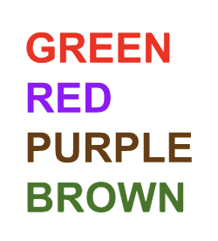

*Figure 1 - Original Stroop test words*

Words were also printed in black and the colours were also presented in squares/swastikas. The reading stimuli was measured focusing on the time difference between reading the coloured word and reading the same word written in black ink. The naming of colour stimuli was measured considering the time difference between naming colours from words and same colours from squares/swastikas.

Stroop [6] concluded that the colour stimuli doesn’t significantly affect the time for reading words, however the word stimuli caused an increase of 74.3% in naming colours.

As demonstrated in [2], by presenting individuals with stimuli that vary in two dimensions, the Stroop test proves that people have a natural capacity for selective attention and that some stimuli can be ignored, escaping attentional control.

According to [4], our life is full of distractions on a daily basis. Some can be easily ignored while others not so much. One example is auditory distraction that affects our cognitive process.

However, as mentioned earlier [1], there are studies that differ on how noise affects cognitive performance, with some arguing that this can bring about positive results, while others believing it to have a negative impact. This is the main factor that motivated this study; to investigate how the results of Stroop test can be affected due to external audio/distractions.

Since the original Stroop was presented, many other variations have been developed. For example, the Auditory Stroop tests, where audio is introduced to the experiment. Steven et al [5] investigated gender associations in adults and children using Stroop tests, in which participants were asked to categorise the gender of voices while being presented with gender-stereotypical words (e.g., dress) and names (e.g., Peter). Dittrich and Stahl [3] also conducted an Auditory Stroop experiment in which an auditory tone is played just before the visual Stroop stimuli. These studies introduced audio to the experiment, but they did not evaluate the impact of trivial noises, like conversations, music, traffic, etc, on traditional Stroop test results.

# **Test Configuration**

In this study, the Stroop test consists of two questions regarding users’ age and gender, a control test and four different environmental tests. Fig 2 illustrates the initial screen. The stats button presents the statistics for each test.

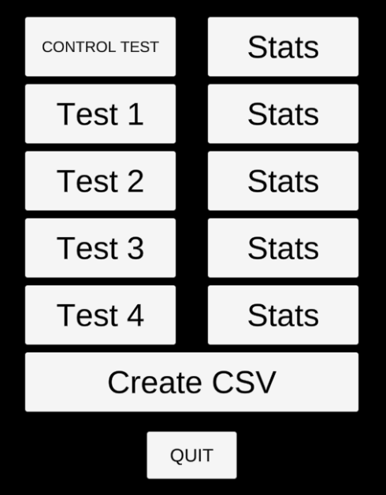

*Figure 2 - Initial screen*

At the beginning of the experiment, an initial control test is conducted to illustrate the basic test procedure and also to determine the participant’s baseline reaction speed. This baseline result is used to offset the performance of each of the following four Stroop tests. The control test does not present incongruence options, it shows only one option per time, in which the word colour matches with the colour name, as shown in Fig 3. No audio is played during the control test and the colour is presented 20 times for selection.

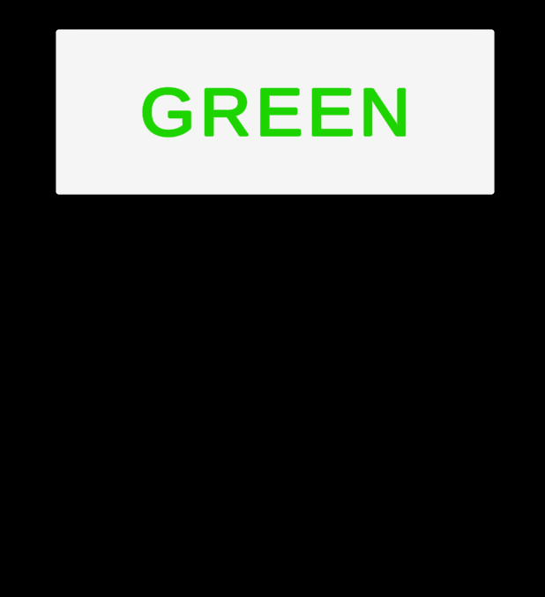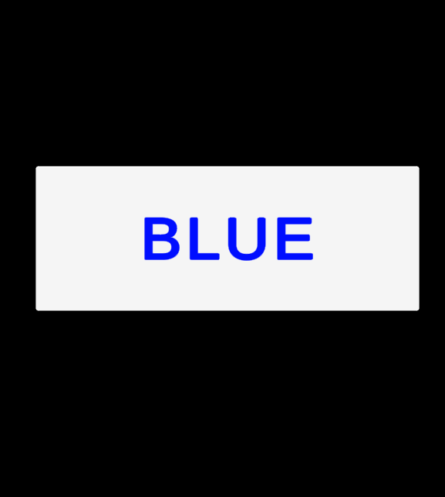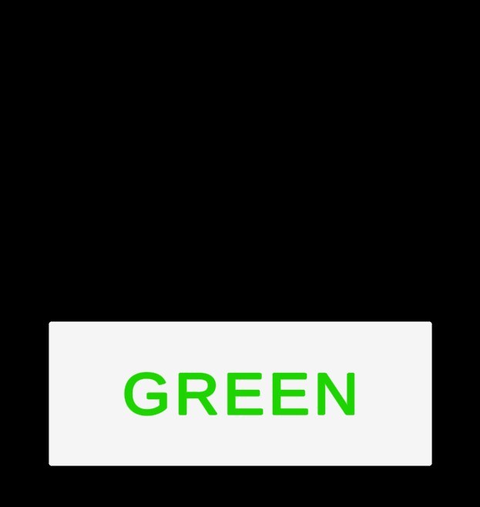

*Figure 3 - Series of control tests*

The four environmental Stroop tests display a list of three words, where two of them are incongruent and only one is congruent (Fig 4). The examinee should select the congruent option in each case. This format is repeated 20 times for each of the four audio environment studies. For each test, a list of words, as illustrated in Fig 4, is presented 20 times, varying both in position and by colour. Different audio environments also accompany each test:

* Test 1: No audio.
* Test 2: Classical music.
* Test 3: Construction noise.
* Test 4: The words green, blue and red are spoken in a random order.

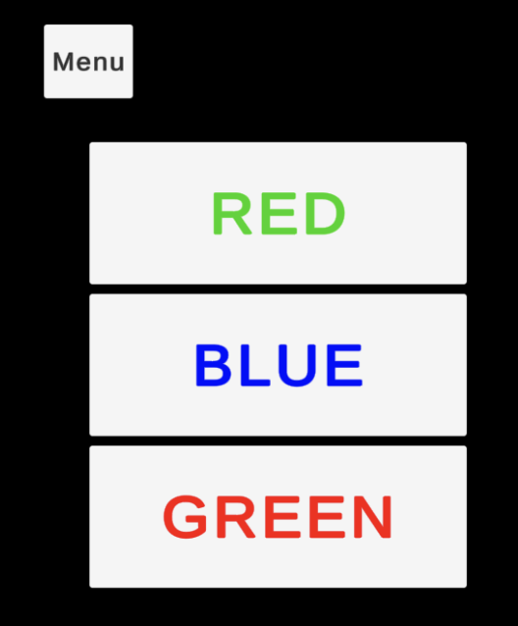

*Figure 4 - Test example*

As shown in Fig 5, once the user has completed all five tests, they can select ***UPDATE CSV*** to store their identification, age and gender on a csv file. If multiple users run the test sequentially, data will be appended to the same file.

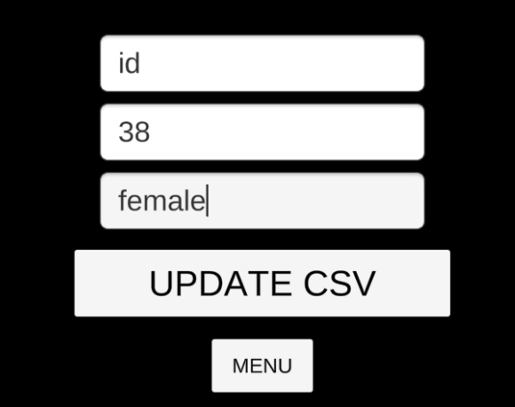

*Figure 5 - Required fields*

For each participant the application records the demographic, response time, and success rate of each test.

* 1. Data Collection

The application was made available via Google Drive and the link was sent to users via email and other communication tools, like Slack and WhatsApp, with a brief explanation and steps to be executed. This is the message sent to the users:  
  
*Hello, can I have 5 minutes of your time? It's for my Master’s Degree engineering project.*

*I'd ask you to run the application shared in the link below then click on Control Test and Start.*

*You have to select the word colour that matches with the colour name.*

*Repeat the same steps for test1, test2, test3 and test4.*

*When all tests are done, then click in Create CSV, fill in the required data and click in Update CSV, you can add any name to the field name.*

*The CSV file will be generated in the same folder where you saved the application.*

*Please send me this csv.*

*Some tests play audio, so a headset is required.*

*Thank you very much for your time.*

*https://drive.google.com/file/d/1qVMy-mg_7NOad7jwyrY8tleFNiB7PKJY/view?usp=share_link*

During the data collection process MacOS users reported issues with saving the CSV file that was not created on some machines due to user privileges. These users were instead oriented to return screenshots of the statistics which are displayed via the ***Stats*** button on the application. After one week, data from 48 users was obtained, all files were merged and the data collection was concluded.

Fig 6 shows a sample of the original CSV files obtained from users. In this figure, the first column, which contains user ID information, is redacted to avoid exposing participant information..

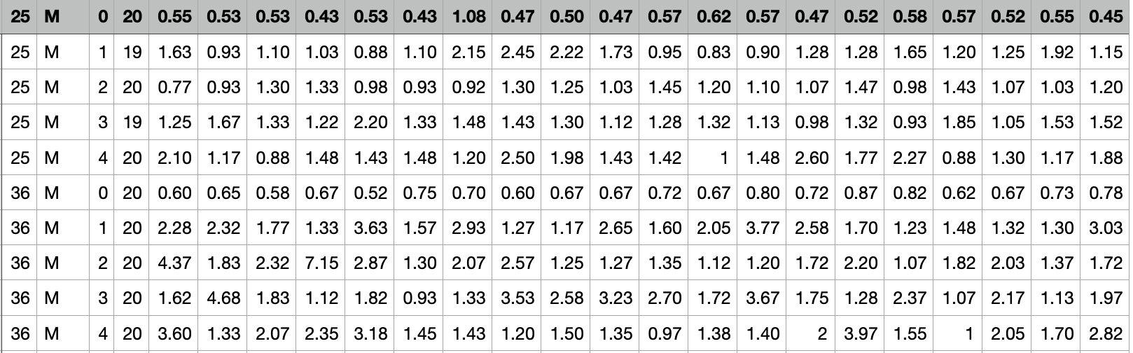

*Figure 6 - CSV response file before sanitising*

A manual process was performed to have data in a good format for analysis:

* Added headers to each column as the file provided by the application did not add it automatically.
* Formatted *gender* field to either ‘male’ or ‘female’.
* Add a new column called *Nationality* adding the corresponding country of each participant.
* Identify the fastest response time on the control test to measure the individual physical response time of users with a computer mouse. This time was subtracted from the response times for tests 1 to 4 in order to establish the actual cognition response time.
* Replaced users’ name provided in the first column by a sequential identifier.

Fig 7 shows data after sanitising.

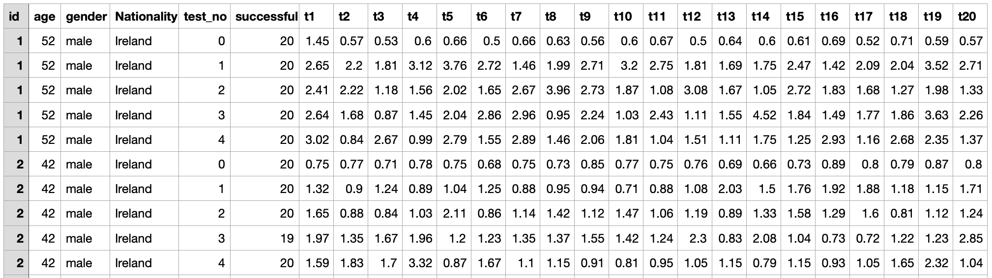

*Figure 7 - CSV response file after sanitising*

# **Results**

Data analysis was performed by using Python as programming language, Anaconda[1], JupiterLab[2] and Matplotlib[3] and the first step was to explore data. An initial analysis identified that the majority of participants are female and from Ireland, as we can see on Fig 8.

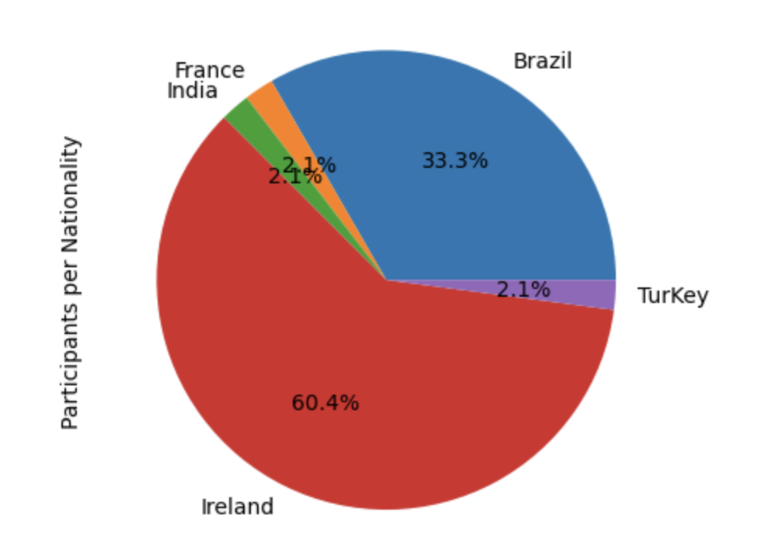 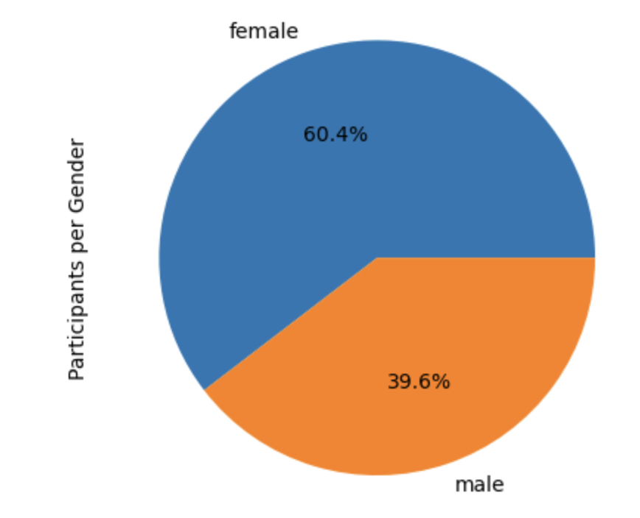

1. *(b)*

*Figure 8 - Participants by nationality (a) and gender (b)*

The age of the majority of participants is between 35 and 45 as shown on Fig 9.

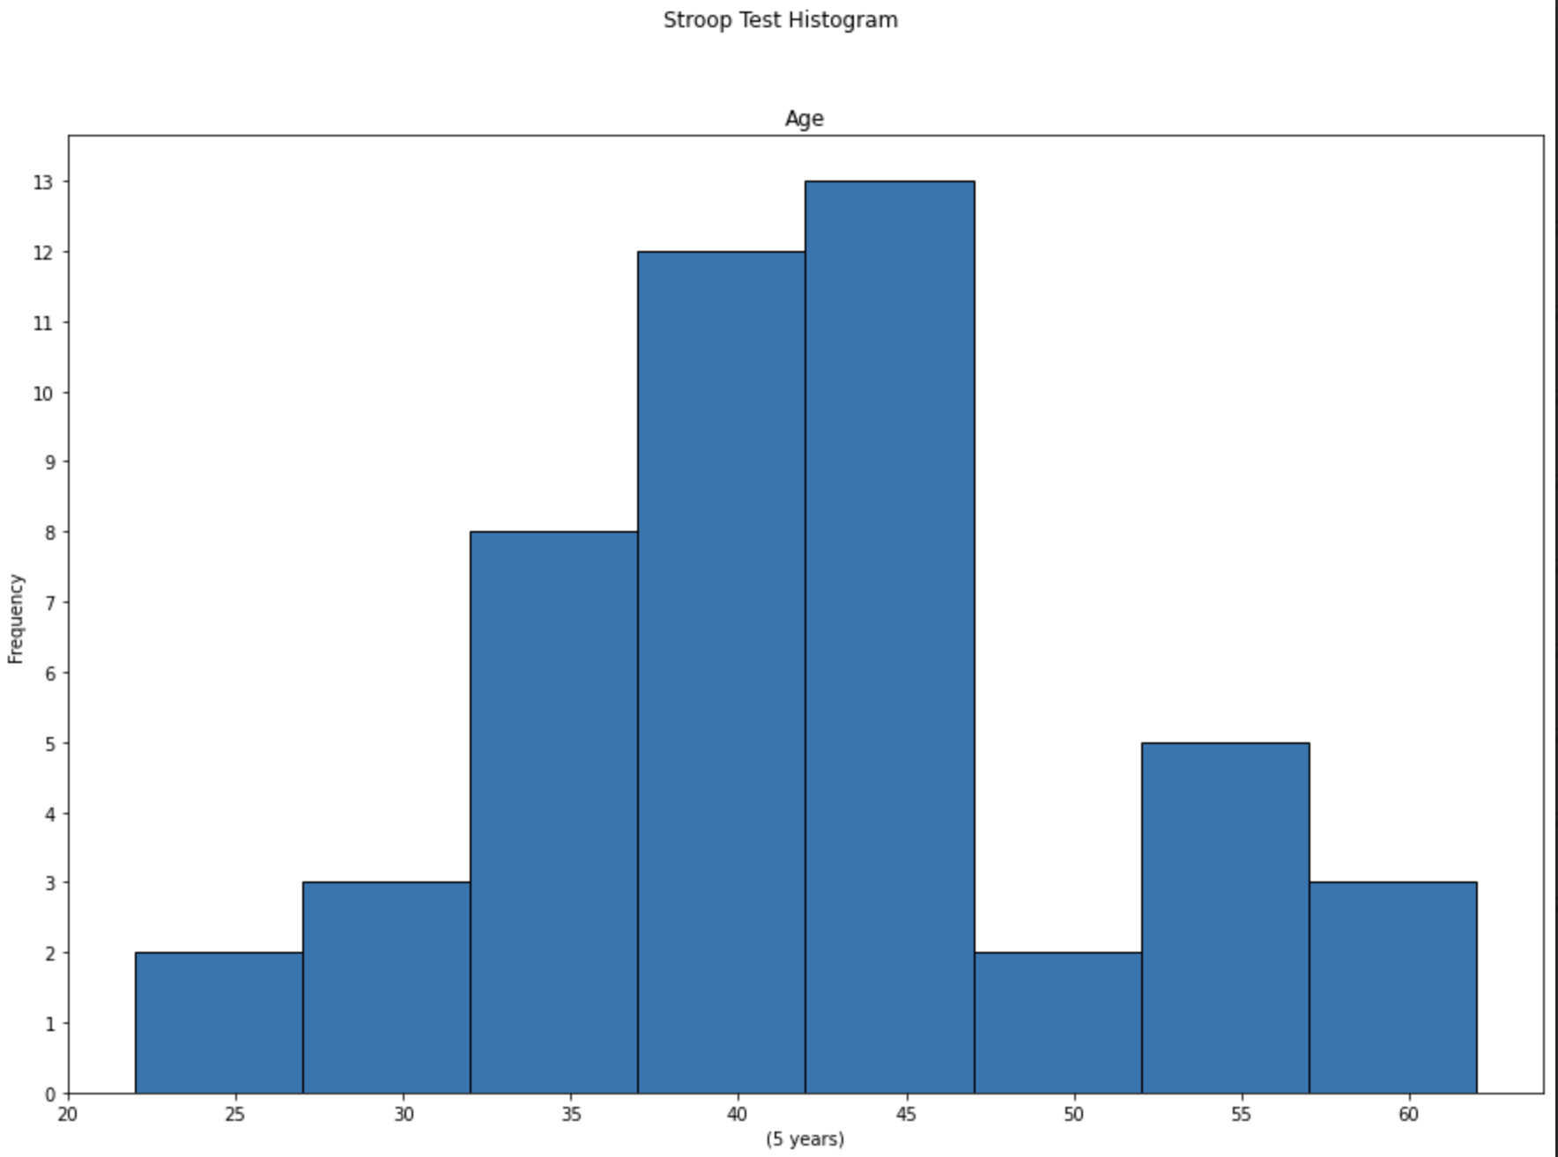

*Figure 9 - Participant's age*

For each test, the first two response times were disregarded as too often this led to unreliable response times. This is typically down to users not beginning the test right away, perhaps due to distractions. For this reason, statistics were calculated on the final 18 response times of each test.

Table 1 presents the main metrics for each response time regarding test 1, 2, 3 and 4. The metrics min and max, which can vary between 0.7s and 31s, and the standard deviation indicate that some participants were quite possibly distracted with other tasks when beginning the test.

|  | **t1** | **t2** | **t3** | **t4** | **t5** | **t17** | **t18** | **t19** | **t20** |
| --- | --- | --- | --- | --- | --- | --- | --- | --- | --- |
| **mean** | 3.3 | 2.2 | 2.0 | 2.1 | 2.0 | 2.1 | 2.1 | 2.1 | 2.1 |
| **std** | 2.9 | 1.0 | 0.9 | 1.2 | 0.8 | 1.3 | 1.0 | 0.8 | 1.0 |
| **min** | 0.7 | 0.8 | 0.7 | 0.8 | 0.8 | 0.7 | 0.8 | 1.0 | 0.6 |
| **25%** | 1.9 | 1.5 | 1.5 | 1.4 | 1.5 | 1.5 | 1.4 | 1.5 | 1.5 |
| **50%** | 2.6 | 2.0 | 1.8 | 1.8 | 1.8 | 1.8 | 1.9 | 1.9 | 1.9 |
| **75%** | 3.6 | 2.6 | 2.4 | 2.6 | 2.4 | 2.4 | 2.5 | 2.4 | 2.4 |
| **max** | 31 | 6 | 6 | 12 | 7 | 14 | 7 | 6 | 8 |

*Table 1[4] - Response time metrics*

An initial look at the data showed that the average response time for all tests was around and above 2 seconds. This is pre-calibration and not taking into account the accuracy of each user. In Fig 10 we can see that user response times tend to decrease as the test proceeds, with a slight increase on test 4 (spoken word audio). One reason for improved response times may be that users become familiar with the test structure as the test proceeds.

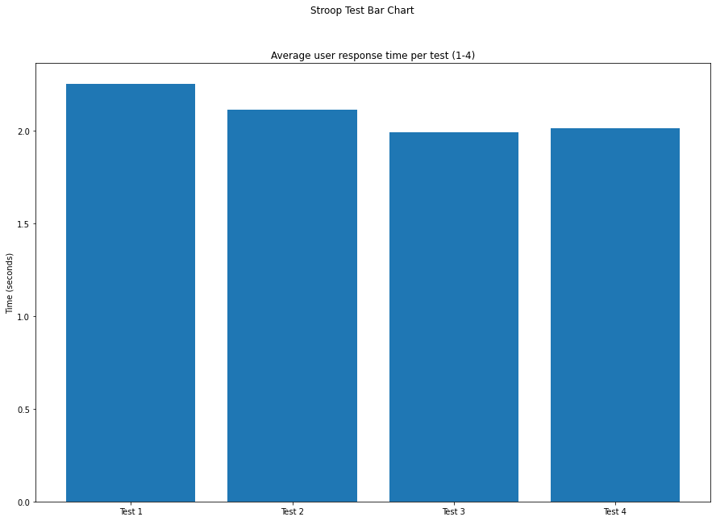

*Figure 10 - Average user response time per test (pre-calibration)*

When comparing the response times between all tests, the same behaviour is observed as it can be seen that most attempts were answered between 1 and 2 seconds, as shown in Fig 11.

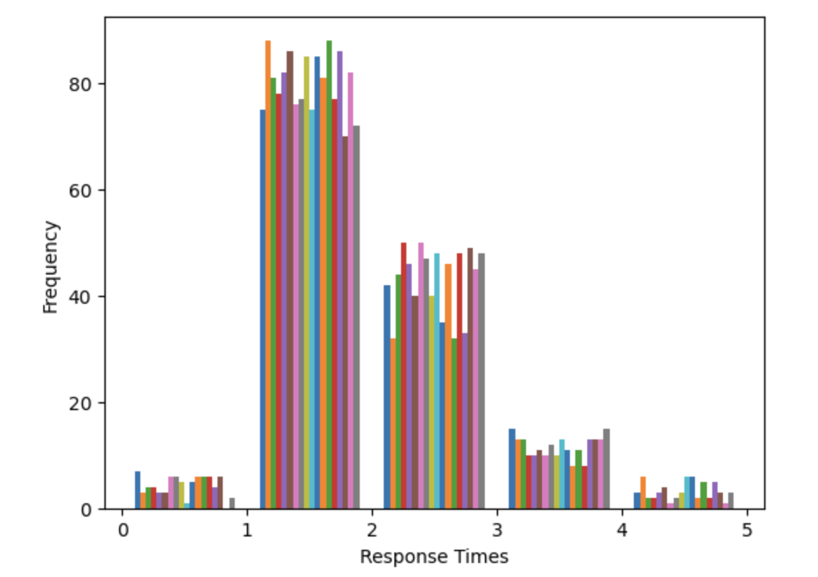

*Figure 11 - Average user response time per attempt*

In order to gain a better understanding of the test time results, it was imperative to separate successful test attempts from erroneous ones. The logic here being that unless the user was perfectly accurate in their test performance, we could not consider lower response times as an indication of high performance.

On Fig 12 Test 1 was removed, as it has no audio, the bars were broken into attempts and records filtered by successful, Fig 12(a), and failed attempts, Fig 12(b). No bias is identified between the different attempts, since response time varies independently of the attempts for all tests.

Fig 12(a) has the behaviour quite similar to Fig 10 where there are no filters. However, on Fig 12(b) it is possible to observe a longer response time for test 4 in relation to the others. Even the differences being small, this can be considered an indication that Test 4 is more intrusive than the others as participants took long to answer it mainly on failure attempts.

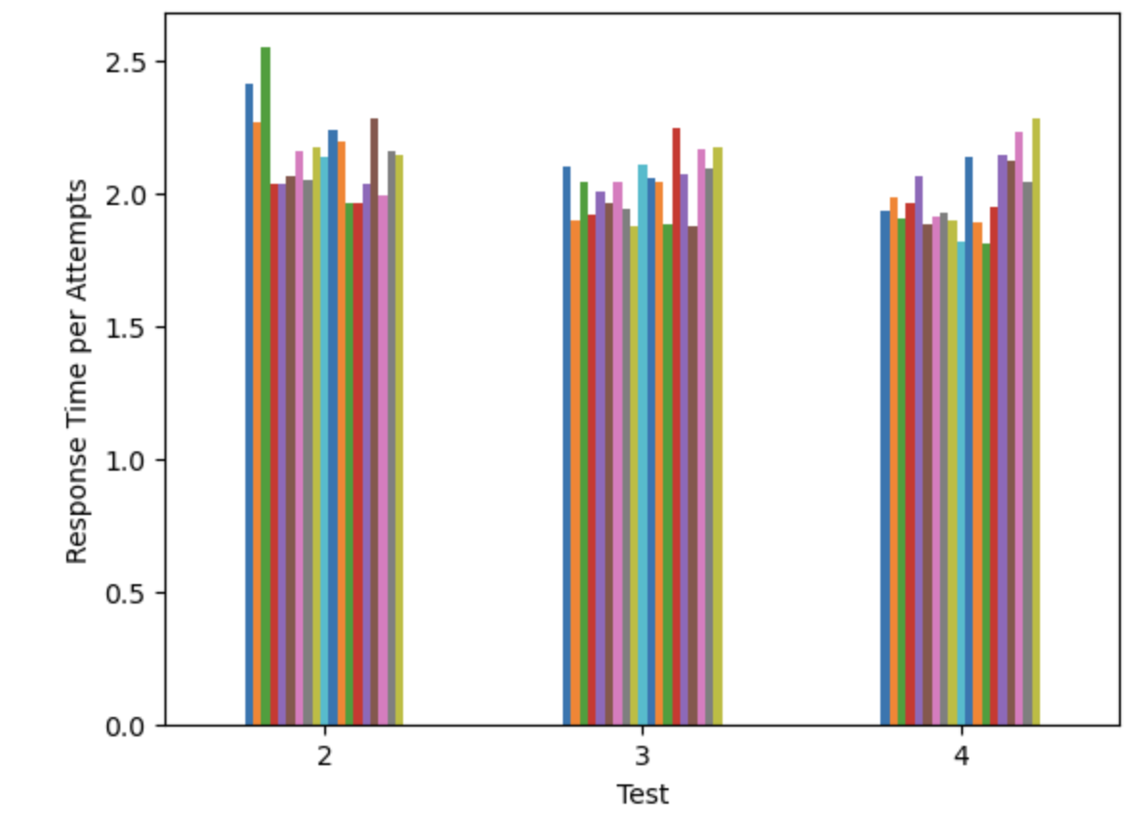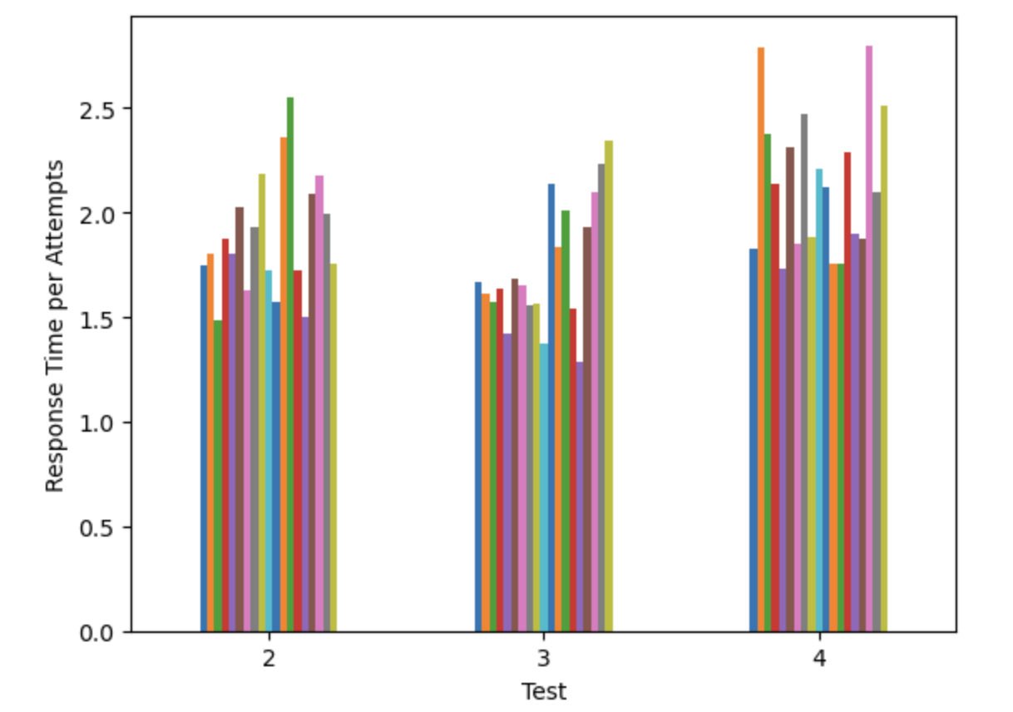  *(a) All attempts (b) Failure attempts*

*Figure 12 - Response time per test attempts and tests*

To confirm that Test 4 is the most intrusive test, a survey was distributed to all participants, requesting them to rate the level of difficulty for each test. Out of the 48 participants, 28 responded to the survey. The results revealed that 64% of the participants classified Test 1 as easy. On the other hand, Test 4 was rated as difficult by 53% of the participants, while only 36% and 10% of the participants found Test 2 and Test 3 difficult, respectively. These data reinforce the conclusion obtained from the experiment’s collected data that Test 4, in which words are spoken while the participant performs the test, is the most intrusive.

Data was calibrated considering the control test findings. The control test measures the individual user’s response time when simply using a computer mouse to click on a target. The fastest control time was chosen for each user, as this represents the optimum reaction time of said user when performing basic hand-to-eye coordination tasks at a computer. The results of control test calibration are displayed in Fig 13, which show that cognitive time for users across all four tests ranges from 1.2 seconds to 1.45 seconds.

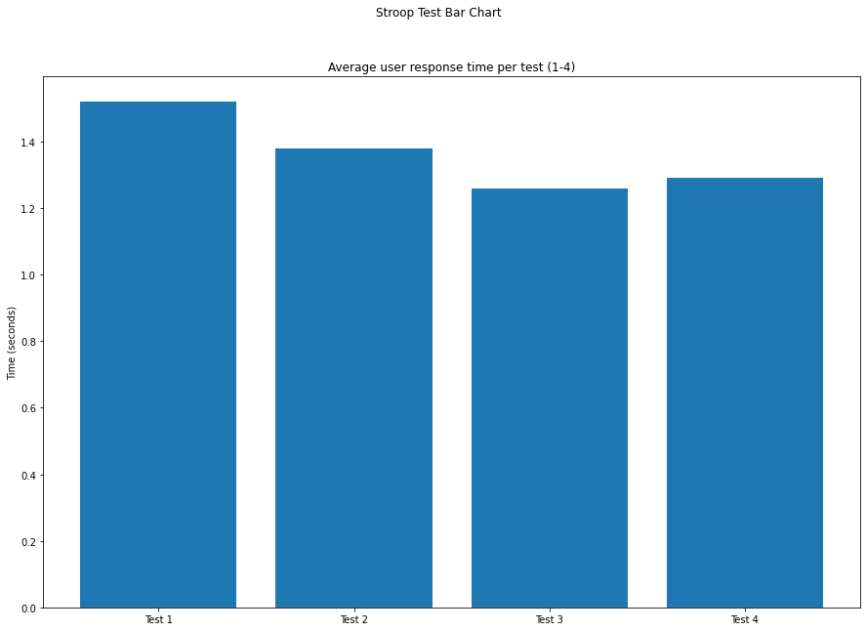

*Figure 13 - Calibrated response times*

Success rate informs us as to how accurately users performed on each test. As visible in Fig 5, users displayed the highest accuracy on test 1, which is the only test without accompanying audio, suggesting that a silent environment contributes to a lower error rate. For tests 2, 3 and 4 users achieved a lower average success rate than test 1, indicating that the auditory stimuli may be contributing to a higher error count.

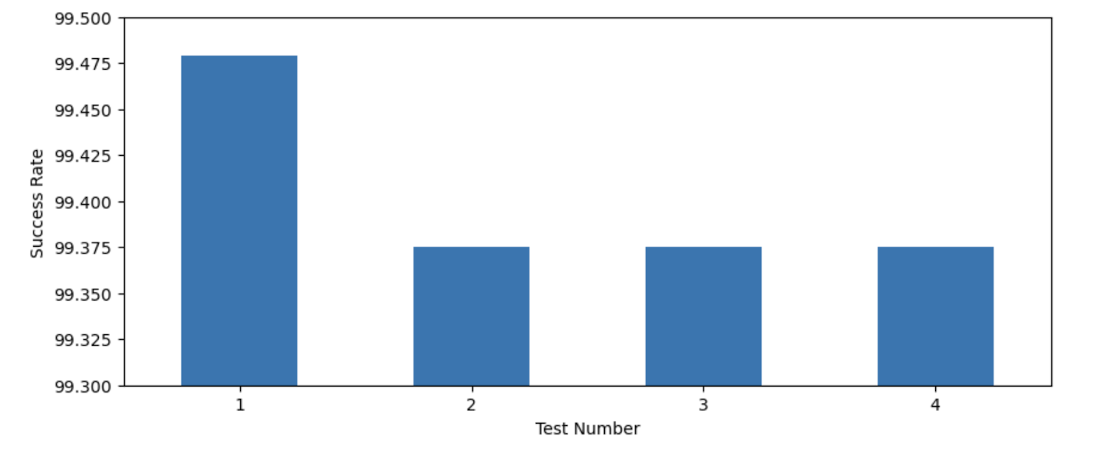

*Figure 14 - Success rate per test (%)*

Test times were analysed when considering only test results with 100% success rate. The findings show that females performed on average quicker than their male counterparts who registered an average response time of approximately 1.5 seconds. Women showed an improvement in response times as the test progressed but this trend was halted with the final test number 4 (spoken word).These findings could suggest that men and women’s cognitive abilities are affected differently depending on environmental auditory stimuli.

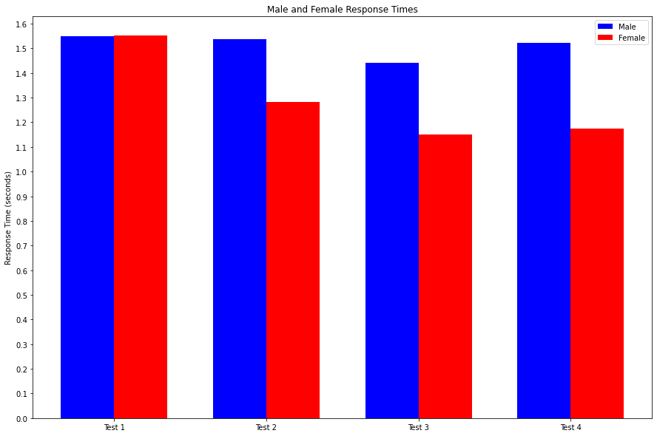

*Figure 16 - Average user response time per test by gender*

User response times were next analysed by age group with Fig 17(a) showing performance for users under the age of 40 and Fig 17(b) showing results for users over 40.

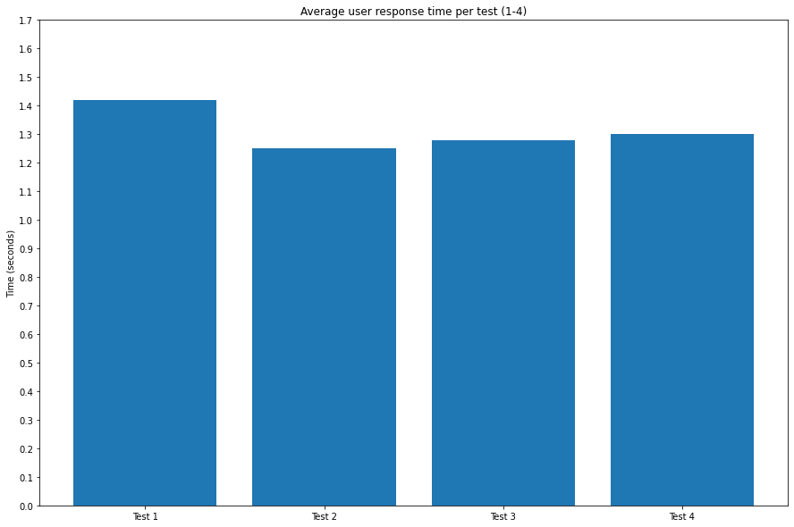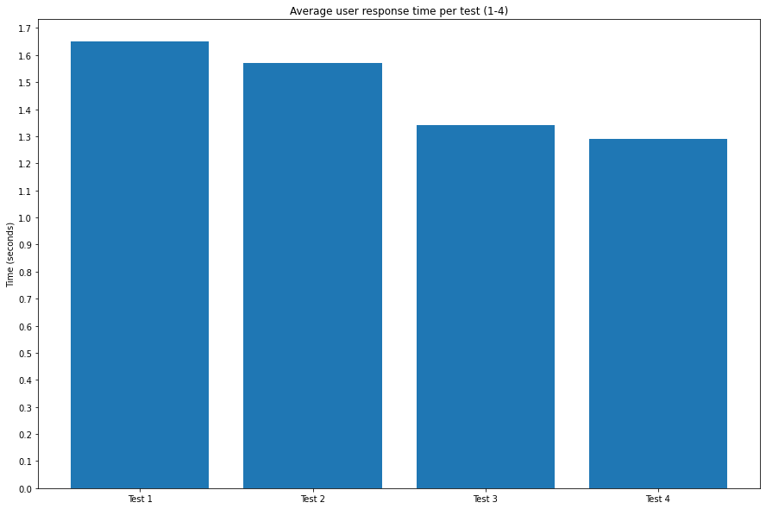

*(a) Age under 40 (b) Age over 40*

*Figure 17 - Response time per test by age group*

The findings in Figure 16 do suggest that the test environments have an effect on user performance when factoring in user age. Users under 40 performed with faster response times overall but there were some noticeable differences as to how each group fared over the 4 tests. Users over 40 started slower but grew into the tests and recorded increasingly faster response times as the tests progressed. On the other hand, users under 40 showed signs of decreasing performance during the later tests 3 (construction noise) and 4 (spoken word), eventually being outperformed in the latter.

# **Conclusion**

Stroop Test is a psychological experiment, originally presented in 1935, that measures individuals’ cognitive flexibility and attention. Since then, many variations have been developed, including the Auditory Stroop test, where audio is introduced.

Some studies include audio as a stimulus where the participant needs to hear the audio to respond to the test, while some other variations add a tone before or during the Stroop stimuli. However, they do not evaluate how trivial noises affect, either positively or negatively, the results of Stroop tests.

This study aimed to investigate how the sounds present in individuals’ lives affect their control of attention and impact the performance of daily tasks. The success rate indicates that regardless of the type of audio it can negatively affect the control of attention, as users performed better on test 1 (no audio). Regarding the different types of audio, the results show lower response times for Test 4 (spoken words) when considering failed attempts, indicating that this would be the most intrusive test.

Considering that the results show some marginal differences between gender-based response times, there may be grounds for further investigation into how men and women are affected by auditory stimuli.

It should be mentioned that in most cases participants performed the tests without supervision, which could affect the results, since there is no guarantee that the user was not distracted by other stimuli.

# **Future work**

Application was developed to run on two different Operational Systems, macOs and Windows, aiming to cover a big number of users. However many users faced issues when running the application on macOs as the CSV file was not created due to a privileges issue.

In a next experiment, it should be considered to implement a Web Application where data would be saved directly to an online database. This improvement removes the dependency of the user local environment and avoids the work of having to merge all files.

Future analysis could be carried out on new and existing data in order to research if there is a link to performance times and native speaking language. There is also room to increase the difficulty of the Stroop test application to include four colour options instead of just three.

The experiment could be repeated in a controlled environment where participants are supervised, for example, in a dedicated room where it is possible to ensure identical testing conditions, free from outside distractions.

Another interesting analysis based on the Stroop test is to evaluate attention control according to the audience. An experiment can be performed to analyse the attention control of participants diagnosed with Autism Spectrum Disorder (ASD) and participants not diagnosed with any disorder.

# **References**

[1] Jafari MJ at el. The Effect of Noise Exposure on Cognitive Performance and Brain Activity Patterns. Open Access Maced J Med Sci. 2019 Aug 30;7(17):2924-2931. doi: 10.3889/oamjms.2019.742. PMID: 31844459; PMCID: PMC6901841.

[2] J. D. Cohen at el. "On the control of automatic processes: A parallel distributed processing account of the Stroop effect," Psychol. Rev., vol. 97, (3), pp. 332-361, 1990. https://www.proquest.com/scholarly-journals/on-control-automatic-processes-parallel/docview/614320835/se-2. doi: <https://doi.org/10.1037/0033-295X.97.3.332> (accessed Feb. 12, 2023).

[3] K. Dittrich and C. Stahl, "Nonconcurrently presented auditory tones reduce distraction," Attention, Perception and Psychophysics, vol. 73, (3), pp. 714-719, 2011. https://www.proquest.com/scholarly-journals/nonconcurrently-presented-auditory-tones-reduce/docview/920257828/se-2 (accessed Feb. 12, 2023).

[4] Lavie, N. (2010). Attention, Distraction, and Cognitive Control Under Load. Current Directions in Psychological Science, 19(3), 143–148. doi: https://doi-org.ezproxy.ait.ie/10.1177/0963721410370295

[5] Steven B. Most, Anne Verbeck Sorber, Joseph G. Cunningham. Auditory Stroop reveals implicit gender associations in adults and children. Journal of Experimental Social Psychology, Volume 43, Issue 2, 2007, Pages 287-294, ISSN 0022-1031. doi: <https://doi.org/10.1016/j.jesp.2006.02.002>.

[6] Stroop, J. R. (1935). Studies of interference in serial verbal reactions. Journal of Experimental Psychology, 18(6), 643–662. doi: [https://doi.org/10.1037/h0054651](https://psycnet.apa.org/doi/10.1037/h0054651).

[7] V. Mueller et al., "The Stroop Competition: A Social-Evaluative Stroop Test for Acute Stress Induction," 2022 IEEE-EMBS International Conference on Biomedical and Health Informatics (BHI), Ioannina, Greece, 2022, pp. 1-4, doi: 10.1109/BHI56158.2022.9926835.

1. Distribution of the Python and R programming languages for scientific computing. <https://www.anaconda.com>
2. Web-based user interface for Project Jupyter. [https://jupyterlab.readthedocs.io/en/stable](https://jupyterlab.readthedocs.io/en/stable/)
3. Library for creating visualisations in Python. [https://matplotlib.org](https://matplotlib.org/)
4. Some attempts were omitted in Table 1 to improve visualisation.